Spring Hibernate Setting

1. Create project :
   1. Spring Legacy Project
   2. Spring MVC project
2. Change pom.xml Overview
   1. Java-version:1.8
   2. org.springframework-version : 4.3.9.RELEASE
   3. org.aspectj-version : 1.8.9
   4. org.slf4j-version:1.7.25
   5. org.apache.tiles.version:3.0.7
   6. org.hbernate-version:5.2.10.Final -> 4.3.11.Final work
3. Add dependency
   1. Spring-test : ${org.springframework-version}
   2. Commons-dbcp : 1.4
   3. Org.hibernate:hibernate-core: ${org.hibernate-version}
   4. Spring-orm : ${org.springframework-version}
   5. Mysql-connector-java : for mysql
   6. Sqljdbc4 : for mssql
4. JBoss Tools install
   1. Hibernate tools
5. 설치가 끝나면 Open Perspective - Hibernate를 선택한 후, Hibernate configuration 창에서 Add Configuration을 선택한다.
   1. Click ProjectName
   2. Database connection
   3. Configuration file
   4. 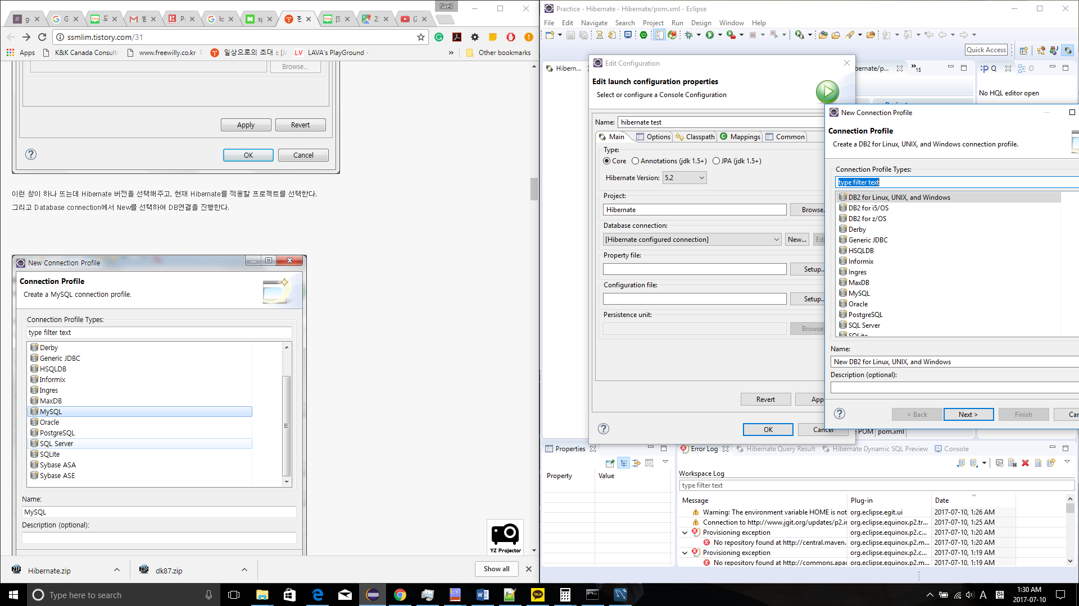
6. 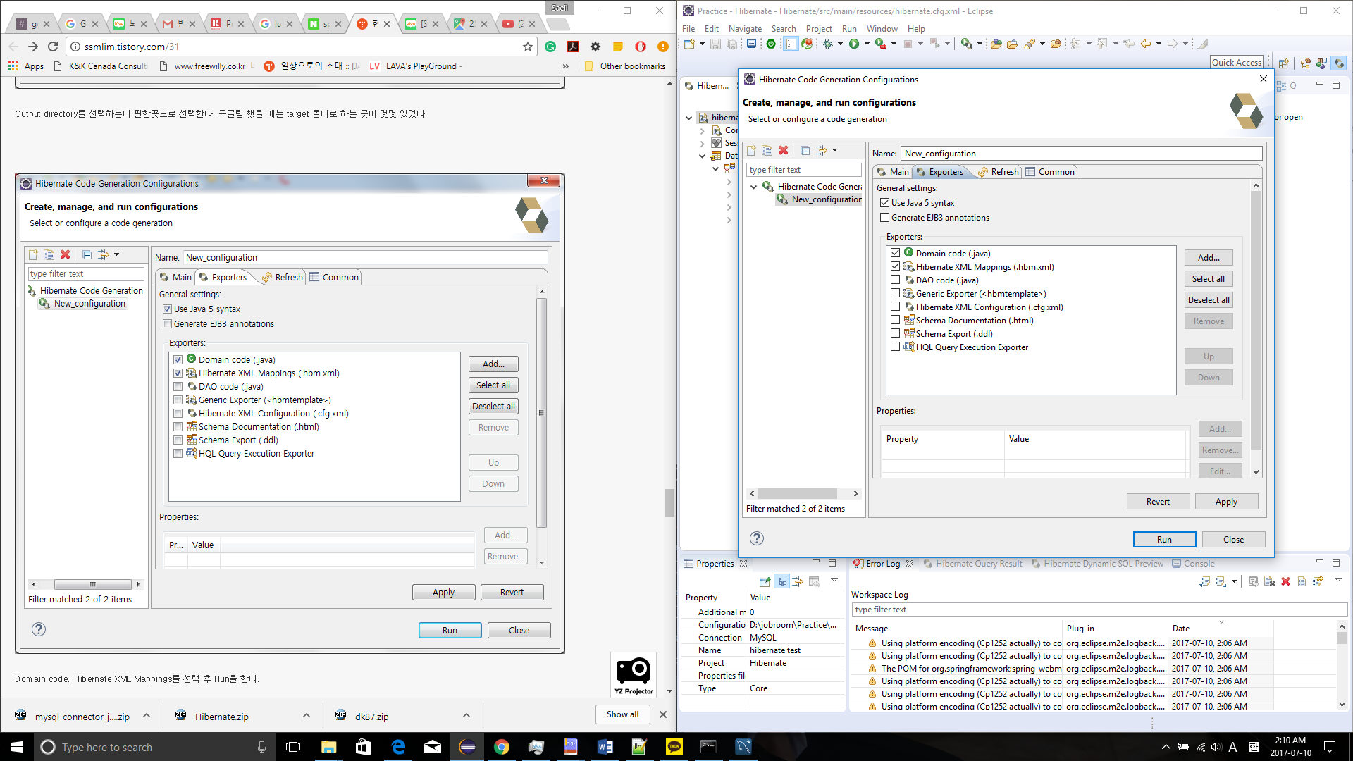
7. Hibernate Code Generation Cofigurations
   1. Output directory
8. 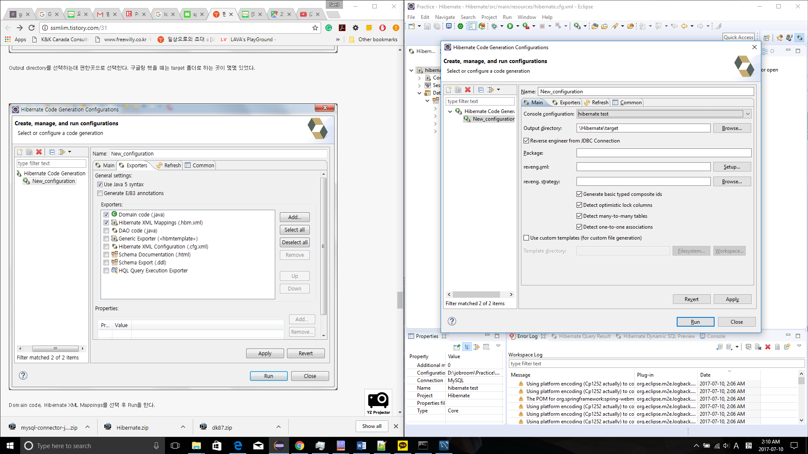

Root-context.xml

<?xml version=*"1.0"* encoding=*"UTF-8"*?>

<beans xmlns=*"http://www.springframework.org/schema/beans"*

xmlns:xsi=*"http://www.w3.org/2001/XMLSchema-instance"*

xsi:schemaLocation=*"http://www.springframework.org/schema/beans http://www.springframework.org/schema/beans/spring-beans.xsd"*>

<bean id=*"dataSourceMySQL"* class=*"org.springframework.jdbc.datasource.DriverManagerDataSource"*>

<property name=*"driverClassName"* value=*"com.mysql.jdbc.Driver"* />

<property name=*"url"* value=*"jdbc:mysql://127.0.0.1:3306/db_springproject"*/>

<property name=*"username"* value=*"root"*/>

<property name=*"password"* value=*"1234"*/>

</bean>

<bean id=*"sessionFactoryMySQL"* class=*"org.springframework.orm.hibernate4.LocalSessionFactoryBean"*>

<property name=*"dataSource"* ref=*"dataSourceMySQL"* />

<property name=*"configLocation"*>

<value>/WEB-INF/spring/hibernate.cfg.xml</value>

</property>

</bean>

<bean id=*"transactionManagerMySQL"* class=*"org.springframework.orm.hibernate4.HibernateTransactionManager"*>

<property name=*"sessionFactory"* ref=*"sessionFactoryMySQL"*/>

</bean>

</beans>

1. Hibernate.cfg.xml

<?xml version=*"1.0"* encoding=*"UTF-8"*?>

<!DOCTYPE hibernate-configuration PUBLIC

"-//Hibernate/Hibernate Configuration DTD 3.0//EN"

"http://hibernate.sourceforge.net/hibernate-configuration-3.0.dtd">

<hibernate-configuration>

<session-factory>

<!-- JDBC connection pool (use the built-in) -->

<property name=*"connection.pool_size"*>1</property>

<!-- SQL dialect -->

<property name=*"hibernate.dialect"*>org.hibernate.dialect.MySQLDialect</property>

<!-- Enable Hibernate's automatic session context management -->

<property name=*"current_session_context_class"*>thread</property>

<!-- Disable the second-level cache -->

<property name=*"cache.provider_class"*>org.hibernate.cache.internal.NoCacheProvider</property>

<!-- Echo all executed SQL to stdout -->

<property name=*"show_sql"*>true</property>

<!-- Drop and re-create the database schema on startup -->

<property name=*"hbm2ddl.auto"*>update</property>

<mapping resource=*"com/spring/hibernate/dao/xml/TbUser.hbm.xml"*/>

<mapping resource=*"TbUser.hbm.xml"*/>

</session-factory>

</hibernate-configuration>